

American International University Bangladesh (AIUB)

**Department of Computer Science**

# Faculty of Science & Technology (FST)

**BUS TRACKING SYSTEM**

A Software Engineering Project

Supervised By - Saeeda Sharmeen

Submitted By: Group 6

|  |  |  |  |  |
| --- | --- | --- | --- | --- |
| **Semester: Summer_23_24** | | **Section: I** | **Group Number: 7** | |
| SN | Student Name | Student ID | Contribution (%) | Individual Marks |
| 1 | TALUKDER HASNAT ZADID | 22-46808-1 | 20% |  |
| 2 | BISHAL ROY | 18-37791-2 | 20% |  |
| 3 | SHRABASTI ADHIKARI | 21-45450-3 | 20% |  |
| 4 | MST.RIMVI RAHMAN | 21-45496-3 | 20% |  |
| 5 | HASAN MAHMUD | 22-47240-1 | 20% |  |

The project will be Evaluated for the following Course Outcomes

|  |  |  |
| --- | --- | --- |
| Your Project will be Evaluated based on the following marking criteria |  | Marks: 20 |
|  |
| Design the System Interface (UI/UX design) | [5 Marks] |  |
| Prepare Test cases and Test plan | [5 Marks] |  |
| Prepare Project Schedule with Effort estimation | [5 Marks] |  |
| Identify potential risks and prepare a risk management plan | [5 Marks] |  |

**UI/UX Design :**

Fig-1.1 : Landing Page Fig 1.2 : Guideline Page 1

Fig 1.3 : Guideline Page 2 Fig 1.4 : Guideline Page 3

Fig 1.5 : Registration Page 1 Fig 1.6 : Registration Page 2

Fig 1.7 : Registration Verification Fig 1.8 : Route Searching Page

Fig 1.9 : Route Selection Page Fig 2.0 : Bus Selection Page

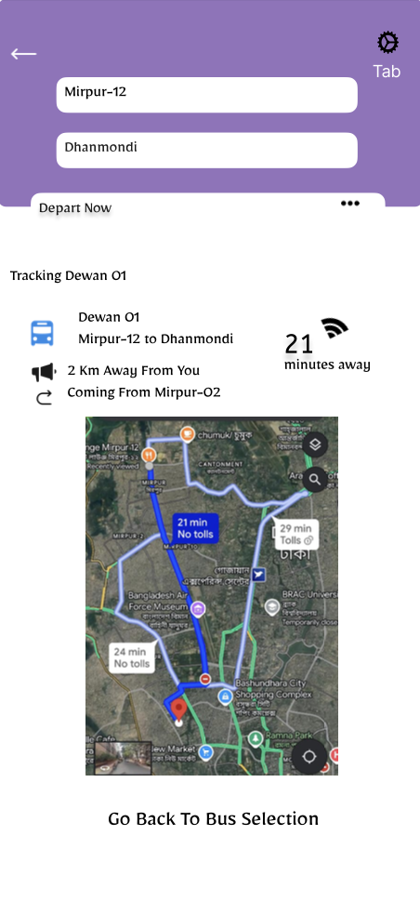

Fig 2.1 : Bus Tracking Page Fig 2.2 : Map Page

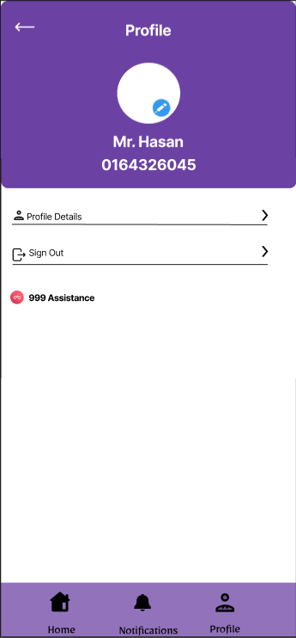

Fig 2.3 : Profile Page Fig 2.4 : User Information Page

Fig 2.5 : Notification Page Fig 2.6 : Helpline Page

**Test Case**

|  |  |  |  |  |  |  |  |  |  |  |  |  |  |  |  |  |
| --- | --- | --- | --- | --- | --- | --- | --- | --- | --- | --- | --- | --- | --- | --- | --- | --- |
| Project Name: Bus Tracking System | | | | | | | | Test Designed by: Hasan Mahmud | | | | | | | | |
| Test Case ID: PAGE_1.4 | | | | | | | | Test Designed date: 11/09/2024 | | | | | | | | |
| Test Priority (Low, Medium, High): High | | | | | | | | Test Executed by: Hasan Mahmud | | | | | | | | |
| Module Name: Log in | | | | | | | | Test Execution date: 15/09/2024 | | | | | | | | |
| Test Title: Registration | | | | | | | |  | | | | | | | | |
| Description: Register using phone number | | | | | | | |  | | | | | | | | |
| Precondition (If any): User Must Have Valid Username and Email | | | | | | | |  | | | | | | | | |
| Test Steps | | Test Data | | | Expected Results | | |  | | | Actual Results | | | Status  (Pass/Fail) | | |
| 1. Go to Sign in 2. Enter Phone Number 3. Click Continue | | 1.Phone  Number | | | Registration Successful | | |  | | | As Expected | | | Pass | | |
| Post Condition: User is successfully registered to the app. | | | | | | | | | | | | | | | | |
| Project Name: Bus Tracking System | | | | | | | | | Test Designed by:  Talukder Hasnat Zadid | | | | | | | |
| Test Case ID: PAGE_1.5 | | | | | | | | | Test Designed date: 11/09/2024 | | | | | | | |
| Test Priority (Low, Medium, High): High | | | | | | | | | Test Executed by:  Talukder Hasnat Zadid | | | | | | | |
| Module Name: Login via Google and Facebook | | | | | | | | | Test Execution date: 15/09/2024 | | | | | | | |
| Test Title: Login Verification | | | | | | | | | | | | | | | | |
| Description: Verify log in with OTP Verification | | | | | | | | | | | | | | | | |
| Precondition (If any): User must enter a valid username and Email | | | | | | | | | | | | | | | | |
| Test Steps | | | Test Data | | | Expected Results | | | | | | Actual Results | | | Status  (Pass/Fail) | |
| 1.Go to the application  2. Enter Username  3.Enter an E-mail   1. Receive OTP 2. Enter the OTP 3. Click on Continue | | | Username:  E-mail:  OTP | | | User should be verified by correct  OTP | | | | | | As Expected | | | Pass | |
| Post Condition: | | | | | | | | | | | | | | | | |
| Project Name: Bus Tracking System | | | | | | | | | Test Designed by:  Talukder Hasnat Zadid | | | | | | | | |
| Test Case ID: PAGE_1.5 | | | | | | | | | Test Designed date: 11/09/2024 | | | | | | | | |
| Test Priority (Low, Medium, High): High | | | | | | | | | Test Executed by:  Talukder Hasnat Zadid | | | | | | | | |
| Module Name: Guest Login | | | | | | | | | Test Execution date: 15/09/2024 | | | | | | | | |
| Test Title: Login to Route Search | | | | | | | | | | | | | | | | | |
| Description: Observe Route Searching Areas | | | | | | | | | | | | | | | | | |
| Precondition (If any): User must enter a valid username and Email | | | | | | | | | | | | | | | | | |
| Test Steps | | | Test Data | | | Expected Results | | | | | | Actual Results | | | Status  (Pass/Fail) | | |
| 1. Click to Continue as guest | | |  | | | User should be able  To access the route  Searching page | | | | | | As Expected | | | Pass | | |
| Post Condition: | | | | | | | | | | | | | | | | | |

|  |  |  |  |  |
| --- | --- | --- | --- | --- |
| **Test Steps** | **Test Data** | **Expected Results** | **Actual Results** | **Status (Pass/Fail)** |
| 1. Go to Location Entry Page |  | The location entry page should load successfully. | Location entry page loaded successfully. | Pass |
| 2. Enter Current Location | Jamuna Future Park | Location should be accepted without errors. | Location accepted without errors. | Pass |
| 3. Enter Destination | Brac,University | Destination should be accepted without errors. | Destination accepted without errors. | Pass |
| 4. Choose Location on Map |  | Map should allow selection of a point. | Map selection functionality not working. | Fail |
| 5. Verify Nearby Buses Appear |  | A list of nearby buses should be displayed. | Nearby buses are not listed successfully. | Fail |

|  |  |  |  |  |  |
| --- | --- | --- | --- | --- | --- |
| Project Name: Bus Tracking System | | | Test Designed by: Bishal Roy | | |
| Test Case ID: PAGE_1.7 | | | Test Designed date: 12/09/2024 | | |
| Test Priority (Low, Medium, High): High | | | Test Executed by: Bishal Roy | | |
| Module Name: Bus Selection | | | Test Execution date:15/09/2024 | | |
| Test Title: User should be able to select bus based on their requirments | | | | | |
| Description: Test application Blood Request page | | | | | |
| Precondition (If any): User must be logged in | | | | | |
| Test Steps | Test Data | Expected Results | | Actual Results | Status  (Pass/Fail) |
| 1. Go to the application 2. Choose Current Location 3. Choose Destination | Users current location and destination | User request should get successful | | As Expected | Pass |
| Post Condition: User can select Bus according to their requirements | | | | | |
| Project Name: Bus Tracking System | | | Test Designed by: Bishal Roy | | |
| Test Case ID: PAGE_1.7 | | | Test Designed date: 12/09/2024 | | |
| Test Priority (Low, Medium, High): High | | | Test Executed by: Bishal Roy | | |
| Module Name: Bus Selection | | | Test Execution date:15/09/2024 | | |
| Test Title: User should be able to select bus based on their requirments | | | | | |
| Description: Test application Blood Request page | | | | | |
| Precondition (If any): User must be logged in | | | | | |
| Test Steps | Test Data | Expected Results | | Actual Results | Status  (Pass/Fail) |
| 1. Go to the application 2. Choose Current Location 3. Choose Destination | Users current location and destination | User request should get successful | | As Expected | Pass |
| Post Condition: User can select Bus according to their requirements | | | | | |

**Summary of Failed Test Cases:**

**1. Real-Time Bus Tracking:**Delays occurred under high user loads.

**2. Notification for Delays:** Notifications were delayed during network congestion.

**3. Offline Mode:** Syncing issues caused outdated information to display temporarily.

**Project Management Plan:**

**Project Scheduling:**

**Effort estimation:**

**1. Identify Critical Features**

From the report, we have several functional requirements. To meet the 4-week deadline, we will focus on the most critical features for an MVP (Minimum Viable Product):

**Essential Features:**

1. **User Login and Authentication**
2. **Real-Time Bus Tracking**
3. **Estimated Time of Arrival (ETA)**

**Additional Features (Post-MVP):**

1. **Notifications and Alerts**
2. **Data Management and Privacy**

**2. Estimate Story Points**

Assign story points based on complexity for the essential features

| **User Story** | **Story Points** |
| --- | --- |
| User Login and Authentication | 5 |
| Real-Time Bus Tracking | 8 |
| Estimated Time of Arrival (ETA) | 8 |

**Total Story Points for MVP**:  
5 + 8 + 8 = **21 Story Points**

**3. Determine Team Velocity**

Assuming the team can handle about **7 story points per week** given the time constraint:

**4. Calculate Sprints Required**

Given the 4-week timeframe, we can structure the sprints as follows:

* **Total Weeks Available**: 4
* **Story Points Per Week**: 7
* **Total Capacity in 4 Weeks**: 7 points/week × 4 weeks = **28 story points**

Since the MVP requires 21 story points, the team can complete this within the available capacity.

**5. Sprint Planning**

Here’s how we can distribute the workload across the 4 weeks:

**Week 1**

* **Focus**: User Login and Authentication (5 points)
* **Activities**: Design and implement user account creation, login, and password recovery.

**Week 2**

* **Focus**: Real-Time Bus Tracking (8 points)
* **Activities**: Implement bus location tracking using Google Maps API; display bus positions on the map.

**Week 3**

* **Focus**: Estimated Time of Arrival (ETA) (8 points)
* **Activities**: Develop ETA calculation based on traffic data; integrate with the tracking system.

**Week 4**

* **Focus**: Finalization and Testing
* **Activities**:
  + Conduct user testing and debugging.
  + Review functionality and refine based on feedback.
  + Prepare for deployment.

**6. Incorporate Reviews and Retrospectives**

At the end of each week, we can include a brief review and retrospective to ensure alignment and incorporate feedback:

* **Week 1 Review**: Discuss user login implementation.
* **Week 2 Review**: Validate tracking feature functionality.
* **Week 3 Review**: Confirm ETA calculations are accurate.
* **Week 4**: Final review before deployment.

**Summary**

* **Total Story Points for MVP**: 21
* **Available Capacity**: 28 story points in 4 weeks
* **Sprint Structure**:
  + Week 1: User Login and Authentication
  + Week 2: Real-Time Bus Tracking
  + Week 3: Estimated Time of Arrival (ETA)
  + Week 4: Final Testing and Review

By focusing on essential features first and allowing room for testing and refinement, this plan ensures the project is delivered within the 4-week timeline while maintaining quality and usability.

**Word Breakdown Structure (WBS) :**

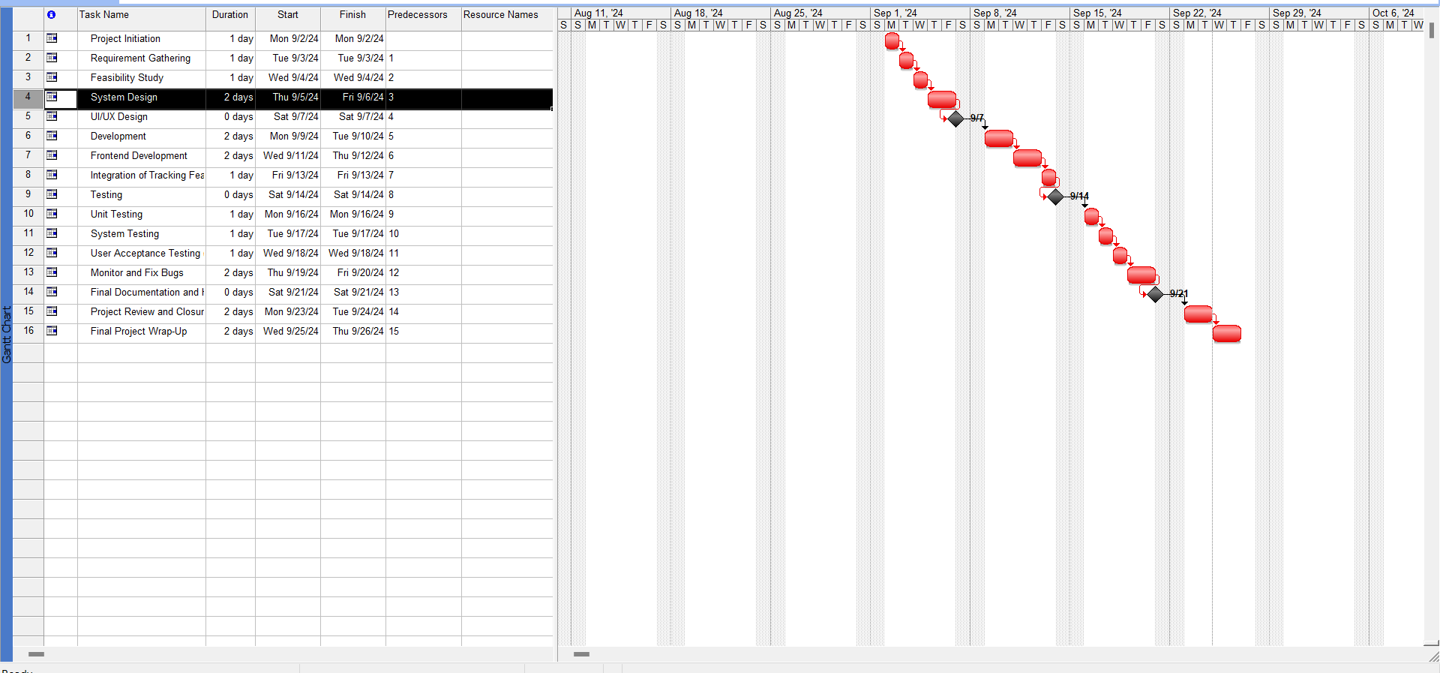

**Risk Analysis:**

1. Technical Risks:

* GPS Signal Inaccuracy: Environmental factors may cause incorrect location tracking.

Mitigation: Use Wi-Fi/cellular triangulation and smoothing algorithms.

* System Integration Failures: Incompatibilities with other systems can cause data issues.

Mitigation: Thorough testing and modular architecture.

* Scalability: System may slow down as user load increases.

Mitigation: Cloud infrastructure with auto-scaling and load testing.

* Algorithm Efficiency: May fail to account for real-time conditions.

Mitigation: Use live traffic data and machine learning.

2. Operational Risks:

* System Downtime: Server issues can disrupt service.

Mitigation: Redundancy and quick-response alert systems.

* Device Failure on Buses: Hardware issues may result in data loss.

Mitigation: Regular maintenance and remote diagnostics.

* Driver Non-Compliance: Drivers might tamper with devices.

Mitigation: Training, monitoring, and penalties.

3. User-Related Risks:

* Low Adoption: Users may be reluctant to use the system.

Mitigation: Awareness campaigns and user-friendly design.

* Poor UX: Difficult interfaces lead to low satisfaction.

Mitigation: UX testing and feedback loops.

4. Data Security Risks:

* Data Breaches: Exposure of sensitive data.

Mitigation: Encryption, secure authentication, and regulatory compliance.

* Location Data Misuse: Potential privacy violations.

Mitigation: Anonymize data and enforce strict policies.

5. Project Management Risks:

* Scope Creep: Uncontrolled feature expansion.

Mitigation: Clear scope and change management.

* Resource Constraints: Shortages in skilled personnel.

Mitigation: Hire early or outsource.

* Timeline Slippage: Project delays.

Mitigation: Realistic scheduling with buffer times.

6. External Risks:

* Regulatory Changes: New laws may impact the project.

Mitigation: Stay updated on regulations.

* Economic/Environmental Factors: Disruptions like economic downturns or disasters.

Mitigation: Contingency planning and infrastructure redundancy.

Risk Matrix Summary:

|  |  |  |  |  |
| --- | --- | --- | --- | --- |
| Risk | Probability | Impact | Risk Level | Mitigation Strategy |
| GPS Signal Inaccuracy | Medium | High | High | Implement multi-source tracking and filtering algorithms |
| System Integration Failures | Low | High | Medium | Thorough integration testing and modular architecture |
| Scalability Issues | Medium | Medium | Medium | Cloud-based infrastructure and load testing |
| Device Failure on Buses | Medium | Medium | Medium | Remote diagnostics and regular maintenance |
| Data Breaches | Low | High | Medium | Encryption, secure authentication, compliance with laws |
| Low User Adoption | Medium | High | High | Awareness campaigns and continuous feedback loops |
| Scope Creep | Medium | High | Medium | Define scope clearly and manage changes effectively |

**Potential Risks in Project Development and Mitigation Plan**

1. Technical Risks:

* Risk:Integration Issues with APIs (e.g., Google Maps, GPS)
* Description: Challenges may arise when integrating third-party APIs, leading to delays or performance issues.

Mitigation Plan:

* Conduct thorough research and testing of APIs before implementation.
* Develop a prototype to test API integration early in the project.
* Maintain close communication with API providers for support and updates.
* Risk:Inaccurate GPS Data
* Description: Inaccurate or delayed GPS data can lead to poor user experience and trust issues.
* Mitigation Plan:
* Implement fallback mechanisms (e.g., historical data) to estimate bus locations.
* Regularly monitor and validate the GPS data accuracy during development.

2. Project Management Risks:

Risk:Scope Creep

* Description: The project may expand beyond the original requirements, leading to increased costs and timelines.
* Mitigation Plan:
* Clearly define project scope and requirements at the outset.
* Use a change management process to evaluate and approve any additional requests.
* Regularly review project milestones and timelines to ensure alignment with goals.
* Risk:Underestimation of Effort and Resources
* Description:Underestimating the time or resources needed can lead to project delays.
* Mitigation Plan:
* Use detailed task breakdown and estimation techniques.
* Review estimates with the team and adjust based on feedback and historical data.
* Include buffer time in the project timeline to accommodate unexpected challenges.

3.Human Resource Risks:

* + Risk:Team Member Turnover
  + Description:Losing key team members can disrupt progress and delay project completion.
  + Mitigation Plan:
  + Document processes and knowledge sharing to ensure continuity.
  + Foster a positive work environment to enhance team retention.
  + Cross-train team members to ensure coverage for critical tasks.
  + Risk:Skills Gap
  + Description:Team members may lack specific skills required for the project, leading to inefficiencies.
  + Mitigation Plan:
  + Conduct a skills assessment at the start of the project.
  + Provide training and resources for team members to acquire necessary skills.
  + Consider hiring additional experts or consultants as needed.

4. Quality Assurance Risks:

* + Risk: Inadequate Testing
  + Description:Insufficient testing can lead to software bugs and poor user experience at launch.
  + Mitigation Plan:
  + Develop a comprehensive testing strategy, including unit, integration, and user acceptance testing.
  + Allocate dedicated time for testing in the project schedule.
  + Involve end-users in testing to gather feedback and identify issues early.
  + Risk: Performance Issues
  + Description:The application may not perform well under high user load, resulting in slow response times.
  + Mitigation Plan:
  + Conduct load testing to simulate high user traffic and identify performance bottlenecks.
  + Optimize code and infrastructure based on testing results.
  + Implement a scalable architecture that can handle increased usage.

5. Compliance and Legal Risks:

* + - Risk:Data Privacy Violations
    - Description: Failure to comply with data protection regulations (e.g., GDPR) can result in legal penalties.
    - Mitigation Plan:
    - Conduct a thorough review of data privacy laws applicable to the project.
    - Implement data encryption and anonymization techniques to protect user data.
    - Regularly review and update privacy policies and practices in accordance with regulations.
    - Risk: Licensing Issues with Third-Party Software
    - Description:Use of unlicensed software or APIs may lead to legal repercussions.
    - Mitigation Plan:
    - Ensure all third-party tools, libraries, and APIs are properly licensed.
    - Maintain a record of all software licenses and ensure compliance.
    - Review licensing agreements regularly to avoid violations.

THE END